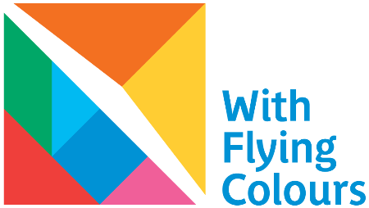
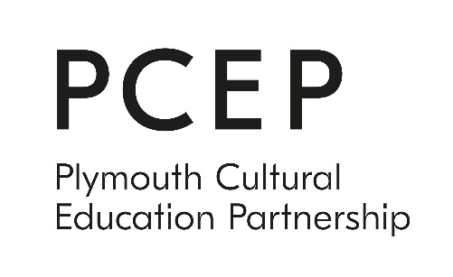

With Flying Colours – Theatre Commission

With Flying Colours is an exciting new play-making programme for young people in areas of low cultural engagement and high deprivation in Plymouth. Working in local schools, children will co-create plays based on their own ideas and words supported by professional writers. Each school will develop their ideas into performance pieces which will pop up in the local community in a whole manner of unlikely spaces and places.

These performances will have high production values. Parents and community members will have the opportunity to meet industry professionals and learn new skills which can be used to support the young people through a variety of practical community based ‘making’ workshops. This will include costume design, making props and building sets. The year will culminate with the school plays that have been developed featuring alongside a professional production in a community based festival in July.

The Brief
Plymouth Cultural Education Partnership (PCEP) are looking to co-produce a professional production as part of the With Flying Colours programme. We are seeking a South West based theatre company to devise and perform a brand new production co-created with children and young people (aged 8 -13) in Plymouth.
The final performances will be performed by the co-producing company and will feature a young, ensemble cast drawn from the partner schools.
The commission involves a period of research and development workshops with the schools (4 primaries and 1 secondary) participating in With Flying Colours. These workshops will develop the content, themes and narrative of the play which captures the voice of the children and young people. These ideas will then be shaped by the company into a one act play of 45 mins in length.
The piece will be performed up to 10 times in community venues as part of the With Flying Colours Festival in July 2020.
Ideally the co-production will be capable of being performed by the co-producing company alone and be used as an advocacy tool for With Flying Colours participants in future years.

The Process
The creative process should take the following structure starting in January 2020 with the final performances taking place in July 2020.
Schedule | Dates | Who
Appoint co-producing company | December 2019 | PCEP
Company R&D in schools(40 hours) | Jan/Feb 2020 | Company
Co-producing company recruit CYP to perform | Mar 2020 | Company
Rehearsals | Jun 2020 | Company
Performances as part of WFC Festival | Jul 2020 | Company
Evaluation | Co-pro company | Company & PCEP

Applications
To apply please send:
- A covering letter, max 2 sides of A4 max, explaining your company’s experience in developing work for children and young people and how you would approach this opportunity.
- An example of two previous works (extracts of script or video trailers)
- A brief outline of how you would approach the development period
- Two professional referees that can demonstrate your company’s suitability for the role
We encourage applications from companies with experience in participatory work and a demonstrable background in devising work, both with and for children and young people.

Fee
The fee for the development, creation and performance of this new production is £20,000 inclusive of travel and accommodation.
This fee has been worked out as follows:
- R&D phase - £4000 (based on 40 hours at £100 per hour)
- Rehearsals - £8760 (based on 4 actors and a director for a 3 week rehearsal period)
- Performance - £2240 (based on 4 actors performing up to 10 times)
- Costume & Set design and build - £3000
- Accommodation and expenses - £2000
*N.B The above is a guide and is flexible to the approach of your company.

Deadline
Wednesday 27th November and interviews will take place on Tuesday 3rd December 2019 at TR2, Production and Learning Centre, Neptune Park, Plymouth, PL4 0SJ
For more information or to have a conversation before applying please contact Ben.Vleminckx@theatreroyal.com or call 01753 230544

