Plymouth Laureate of Words

Recruitment brief

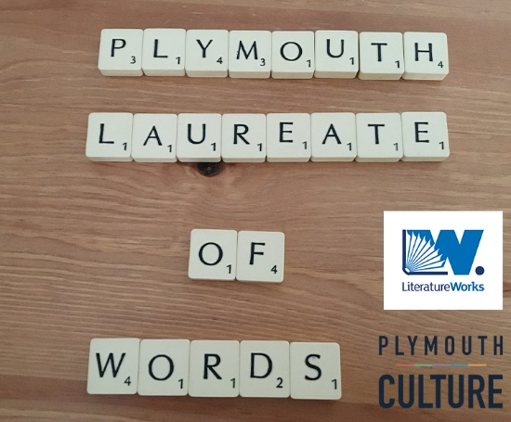

Plymouth has a rich history of literary connections and a burgeoning literature scene with numerous writing groups and a welcoming community of live readers and performers. Following Thom Boulton’s successful term as the city’s second Poet Laureate, we are now seeking the next talented wordsmith to take up the prestigious role of Plymouth’s Laureate of Words. You could be a novelist, playwright, poet, spoken word artist or storyteller. If you’re a wordsmith, we want to hear from you.

The city’s Laureate of Words will act as a communicator of local views, reflecting the city’s voices and helping to illuminate its life, culture and stories. The locally based Laureate will be commissioned to write and present bespoke literature through a mixture of publicly accessible programmed event and city commissioned creative writing. They will meet the Plymouth community to inspire and encourage them and will contribute to important civic events and festivals.

What is expected of the Plymouth Laureate of Words?
If you are selected to undertake this position you will:
- Take literature to a variety of audiences across the city
- Explore and challenge Plymouth’s history, culture and people through writing, and hold an important ceremonial role
- Offer learning opportunities to students, local writers, community projects and creative groups in Plymouth through workshops and talks.
- Develop your skills and creative practice

What can you expect from us?
In return we offer an exciting opportunity to engage with the city of Plymouth. Opportunities to meet members of the community, organisations and key players in the city will enrich both your responses to agreed commissions and your own creative development. As well as the opportunity to be involved in the laureateship programme of activity, this two-year tenure is an opportunity to develop your creative practice and boost your profile.

Plymouth Laureate of Words term and fees

The Plymouth Laureate of Words would take part in a programme of public engagements and commissioned creative writing outputs for a term of two years beginning in January 2021. The Laureateship is a ceremonial role and will come with some civic engagements. You will be representing the city and exploring ways to connect literature to other art forms and projects in the city.

The fee attached to this position is a minimum of £4,000 over two years, approximately £2,000 in each year. This fee is inclusive of travel expenses and VAT. This fee will be paid to a payment schedule, to be agreed with the successful candidate, following the submission of invoices at agreed points across the two years.

Suggested programme of activity
Here, we set out a suggested programme of activity for the laureateship, to encompass the two year term. We are open to discussion about precise outcomes with the appointed candidate.
As Laureate of Words, you will undertake:

-A minimum of two events with a local school or group of young people
-A minimum of two public events or workshops for a general audience in the city (live or online)
- A minimum of one writing course or activity (either asynchronous and digital or in a physical space). This would be produced and promoted with the support of Literature Works.
-A minimum of one other event which may be determined by other city partners
-Up to six Laureate of Words commissions to be delivered by the writer at agreed periods throughout the laureateship. These to be published and promoted online and in other media (local papers etc.) by Literature Works and partners

Process and key dates
-The Plymouth Laureate of Words will be in post for two years beginning in 2021.
-10 candidates will be longlisted by a panel including Literature Works, Plymouth Culture, Dr. Sarah Chapman, Artistic Director of the Arts Institute Plymouth and Louisa Adjoa Parker, poet and co-founder of The Inclusion Agency.

Candidates who are longlisted will be invited to attend a closed event hosted by Literature Works on Crowdcast on Monday 26th October 2020. This event will be an opportunity for the city’s shortlisting panel including Literature Works, Plymouth Culture, Plymouth City Council, the University of Plymouth, Louisa Adjoa Parker, poet and co-founder of The Inclusion Agency, Andrew Brewerton, Plymouth College of Art, William Telford, Plymouth Herald and former Poet Laureate Thom Boulton to meet the candidates and hear them read an extract of their work and find out more about why they are interested in the role. Five candidates will then be shortlisted. This event will be recorded and your portion of film will be used in a public polling process wherein the community will choose their laureate. Other shortlisting panellists will be confirmed shortly.

- From Monday 2nd – Monday 16th November, the videos recorded from the shortlisting event will be made available via the Literature Works website and members of the community will be asked to vote for their Plymouth Laureate of Words. The candidate with the highest number of votes will be appointed as the city’s next Laureate of Words.

-The successful candidate will be notified by 5 pm on Wednesday 18th November.

-The Plymouth Laureate of Words will be invited to attend an official announcement event on Friday 4th December. This will take place in person (at social distance) or online via Crowdcast, depending on Government guidance.

*If you apply for this post, please ensure that you are provisionally available on 26th October and 4th December. *

Submission criteria
-Open to any genre (with the exception of journalism and pure non-fiction)

-Open to people aged 20+

-The Laureate of Words must live in the city.

-The Laureate of Words must be confident in reading their own work and engaging with audiences in public

How to apply
Please send:
A personal statement of up to 500 words outlining interest in the role and addressing publishing history or experience.

Links to relevant examples of work/ portfolio/ Youtube channels or similar (if relevant)
Two pieces of writing (or audio files if spoken word) – Poetry should be a maximum of 65 lines, written work should be no more than 1,500 words. Audio files should be recorded in MP3 format and emailed or sent via WeTransfer. Audio files should be a maximum of 5 minutes in length.

One piece can be on any theme, one should have the theme of ‘The City of Plymouth’ and should respond to this in the writer’s chosen form.

These documents should be collated via email to info@literatureworks.org.uk by no later than 5 pm on Monday 5th October 2020. Applications are accepted online only, we cannot accept postal applications at this time.

Please note: The initial shortlisting event will take place online, via Crowdcast hosted by Literature Works. There will be an official announcement event on 4th December, this may take place online or at social distance in person (depending on Government guidance). We will constantly monitor the ongoing developments around Covid-19 and will put provisions in place to accommodate the public programme for the Laureateship if social distancing measures are still in place next year.

Deadline for applications – Monday 5th October 2020, 5 pm.

