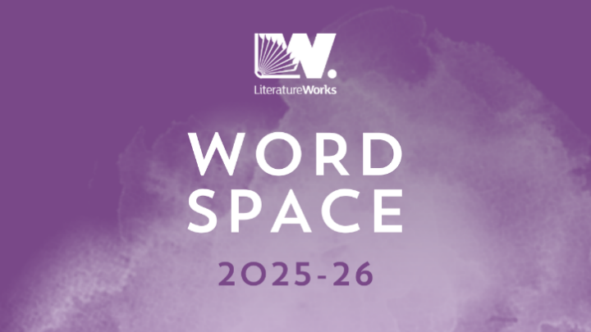
Word Space 2025-26

Online talent development programme

How to apply
December 2024

Word Space 2025-26 is Literature Works’ annual online talent development programme, running from April 2025 to March 2026. Submissions are open throughout December 2024 to January 2025. Word Space will support a group of writers from across the South West to develop their work through mentoring from established writers, peer support, industry insight, advice sessions with Literature Works staff, and access to a growing network of writers.

Word Space is for developing practitioners who are serious about their work. Participants are selected through an open process of anonymous submissions. Participants are invited to set their own creative writing goals at the outset, reviewing and refining during the twelve months of the programme, with support from their mentor and an online peer writer group.

Word Space is delivered online as a digital programme which supports new writing, inclusivity and knowledge exchange in innovative ways. Word Space is produced by Literature Works working with partners who share our focus on inclusive, diverse writer development opportunities, reaching out to underrepresented groups and to underserved, rural locations. The programme provides online spaces for the group to collaborate and feedback, adding to this ongoing one-to-one mentoring and monthly presentations from industry insiders.

Structure
The Word Space 2025-26 group will come together as follows:

- Peer support writing group: - ongoing group feedback and support using a specially curated Slack space. A mixed genre group, designed, curated and moderated in Slack as a ‘Word Space’, where participants can interact, share reading recommendations and post their work in preparation for -
- Writing Workshopping sessions on Zoom: facilitated by an established writer, each participant will submit writing for group workshopping feedback at a live session at least twice in the year. There are four sessions during the year, taking place via Zoom, 7 – 9pm online on the second Tuesday of the month (dates below).
- Whole intake Industry Insight Sessions: - once each month for an online industry insight session with Literature Works, partners and other sector professionals – agents, publishers etc. These sessions take place 1-2pm on the second Tuesday of the month.
- One-to-one mentoring: - three scheduled one-to-one mentoring sessions with your assigned mentor. Taking place during set weeks in June, October, and February, Monday to Thursday between the hours of 9am and 5pm (dates below).
- Individual advice: - Literature Works will offer each participant the opportunity to book one of our free online Advice Surgeries, focused on topics such as funding sources, networks, social media and online presence.
- In-person celebration: - A chance to network and meet fellow Word Space writers, Alumni, Partners and Professionals. Hosted at Exeter Custom House in early July (date to be confirmed).

Key Dates & Session Times
Below is a list of all key dates and session times for the Word Space Programme as outlined above. Attendance and participation in all elements is vital to the success of the programme, both for your own writing development and to support the development of others. We strongly encourage attendance to all sessions. Please note them carefully:

- 2nd Tuesday of every month, 1pm-2pm: Industry Insight Sessions (12 in total, from April 2025 to March 2026).
- 2nd Tuesdays of 10th June 2025, 9th September 2025, 9th December 2025, 10th March 2026, 7pm-9pm: Writing Workshopping Sessions.
- Weeks commencing 9th June 2025, 13th October 2025, 9th February 2026. Monday to Thursday, 9am – 5pm: One-to-one mentoring, to be scheduled in conversation with individual mentors.
- July Date TBC: In-person celebration at Exeter Custom House.

Fee
We prioritise inclusion in everything we do and the fee structure for Word Space is subsidised by Literature Works in order to support access. The full fee for the year is £660. A concessionary fee of £330 is available to those who qualify under to the Literature Works Concessions and Bursary policy here. There is a limited pot of additional bursary support for people whose financial circumstances would otherwise prohibit participation. We require payment in advance, but will consider payment by instalment on a case by case basis. We will be in touch with successful applications about payment once the selection process is complete.

How to apply

Please read the submission criteria below carefully before you start your application. Submissions will close at midday on Friday 31st January 2025.
We are hosting Zoom online open briefing events on Thursday 12th December 2024, 1pm-2pm and Thursday 9th January 2025, 1pm-2pm for people interested in finding out more about Word Space before making an application. Book your place here
The detail
This is a chance for a selected group of emerging writers living or working in the South West to secure a year of support, mentoring and peer feedback from established writers and industry professionals.

To be eligible you must:
- Live, work or study in the South West region. (If you do not live in the region, you may be asked to provide evidence of your link to the South West.)
- Be writing creatively in one of four broad genres: fiction (short and long), poetry and creative non-fiction
- Be looking to develop your writing and take it to the next level
- Have done some writing, but still feel you are not a full-time writer, or you might be working in a new genre (for instance, moving from scriptwriting to poetry). You may have had some work published (magazines, online literary journals, competitions) but writing will most likely not be your main source of income. Please note this scheme is not intended for complete beginners to creative writing.
- Be available to commit to: monthly lunchtime industry insight sessions, three one-to-one mentoring sessions with your assigned mentor and four evening workshopping during the year.
- Writers who are currently studying creative writing at higher education level are not eligible to apply to take part in Word Space.

Selection criteria:
Submissions will be assessed anonymously on the basis of the following:
- The quality of work
- Evidence of a commitment to writing professionally
- Demonstrable readiness through clear writing goals.

Deadline and dates
Submissions will close at midday on Friday 31st January 2025. No applications will be accepted after this time. Successful applicants will be contacted in late February, and the public announcement will be made in April 2025.

Submitting your application
Please prepare your application as one document, in Word or PDF format. Please do not include your name on the submission document, as all work will be assessed anonymously. Please upload your submission through our website here by midday on Friday 31st January 2025.
We will require these four elements to your Word Space application document –

- Two-year writing history:
A short statement (200 words max) describing your writing in the last two years. This is your opportunity to also tell us about any projects you have been involved in, particular successes or failures, and how your writing has developed.

- Examples of your writing:
Up to three examples totalling no more than 3,000 words of your creative writing (this is 3,000 words for all three examples, not 3,000 words each). These can be stories, extracts, poems, scenes or creative prose. Please submit these typed. For poems, please submit up to three separate poems of no more than 40 lines each.

Spoken word artists/performance poets, you may submit at least one of your examples as an audio or visual file via WeTransfer to info@literatureworks.org.uk. Please ensure that you adhere to the word count and do not include or reference your name within the audio/visual file. We will pick up your name and email address from WeTransfer.

Please do not send us links to external sources as applications will be assessed anonymously. If you require support to make a submission, please email info@literatureworks.org.uk and we will be happy to help.

- Statement of readiness
A short statement (200 words max) about why you are ready for Word Space now and what your writing goals will be for the year.

- Partner nomination
Literature Works is promoting and delivering Word Space in collaboration with a group of partners who share our focus on writer development, inclusion and diversity. Each of our partners will select one participant to whom they will offer additional support. When you send your submission, you may tell us whether you wish to be considered for one of these nominated partner places. By doing so, you are giving permission for us to share your submission and your contact details with the partner that you select. Your submission will still go through to the main selection process but will also connect you with the partner organisation that you have identified. They will use our set selection criteria to nominate their Word Space participant. Our partnership will help to create a connected network of writer support and development for all applicants. Our partners are:

Artful Scribe - supporting writers in Hampshire, Dorset, and the Solent
Little Toller Books – supporting writing about nature and rural life
The Writers’ Block, Cornwall – an innovative creative writing hub, based in Redruth
Raise the Bar – a leading live poetry night, running blockbuster spoken word events in Bristol since 2014

Access needs
Please let us know about access requirements you may have, and what we can do that would help to remove any barriers.

Terms and Conditions
Word Space is a development programme during which writers will be offered advice and guidance. We require applicants to fill out an Equality Diversity and Inclusion survey as part of your application. The programme will not publish or represent writers. Copyright, as in all cases with programmes of this nature, remains with the writer. The submissions decision is final and we will not enter into discussions about the outcome of your submission. We regret that we cannot return anything submitted with your application.

Literature Works, December 2024

